**Merge two unrelated datasets COVID-19 case data and economic indicators and resolve schema conflicts**

**Objective**

To integrate two unrelated datasets—COVID-19 global data and economic indicators—into a unified PostgreSQL database that allows coherent analysis through structured schema design, data cleaning, normalization, and a unified analytical view.

**Database Setup**

**Create and Connect to Database**

*CREATE DATABASE data_merge;*

*\c merging_db;*

**Data Staging**

**Create Staging Table for Economic Indicators**

*CREATE TABLE stg_economic_indicators (*

*country TEXT,*

*indicator TEXT,*

*year INT,*

*value NUMERIC*

*);*

**Prepare the Economic Dataset File**

*sudo cp /home/main/Downloads/economic_indicators_dataset_2010_2023.csv /tmp/*

*sudo chmod 644 /tmp/economic_indicators_dataset_2010_2023.csv*

**Load Data into PostgreSQL**

*psql -U postgres -d merging_db -h localhost *

*-c "\copy stg_covid_worldwide *

*FROM '/tmp/economic_indicators_dataset_2010_2023.csv ' \”*

**Clean COVID Dataset Using Python**

The COVID dataset had irregularities like "N/A" and empty strings. A Python script was used to clean the data.

*import csv*

*input_path = "/tmp/covid_worldwide.csv"*

*output_path = "/tmp/covid_worldwide_clean.csv"*

*with open(input_path, "r") as infile, open(output_path, "w", newline="") as outfile:*

*reader = csv.reader(infile)*

*writer = csv.writer(outfile)*

*header = next(reader)*

*writer.writerow(header)*

*for row in reader:*

*cleaned = []*

*for cell in row:*

*cell = cell.strip()*

*if cell.upper() == "N/A" or cell == "":*

*cleaned.append("")*

*elif cell.replace(",", "").replace(".", "").isdigit():*

*cleaned.append(cell.replace(",", ""))*

*else:*

*cleaned.append(cell)*

*writer.writerow(cleaned)*

**Create Staging Table for Cleaned COVID Data**

*CREATE TABLE stg_covid_worldwide (*

*serial_number INTEGER,*

*country TEXT,*

*total_cases BIGINT,*

*total_deaths BIGINT,*

*total_recovered BIGINT,*

*active_cases BIGINT,*

*total_tests BIGINT,*

*population BIGINT*

*);*

**Load Cleaned Data into PostgreSQL**

*psql -U postgres -d merging_db -h localhost *

*-c "\copy stg_covid_worldwide *

*FROM '/tmp/covid_worldwide_clean.csv' *

*WITH CSV HEADER NULL ''"*

**Schema Inspection and Verification**

*\d stg_economic_indicators;*

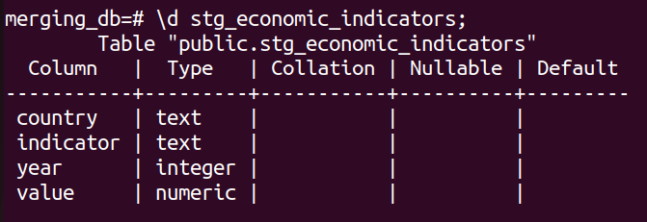

*\d stg_covid_worldwide;*

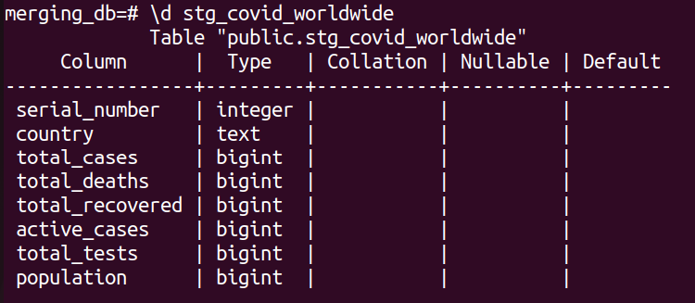

*SELECT * FROM stg_economic_indicators LIMIT 5;*

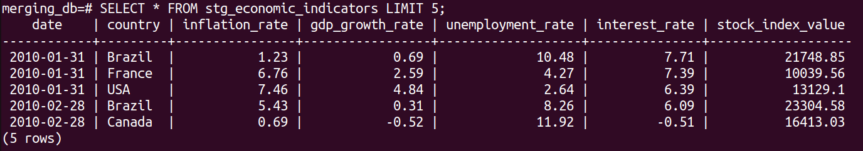

*SELECT * FROM stg_covid_worldwide LIMIT 5;*

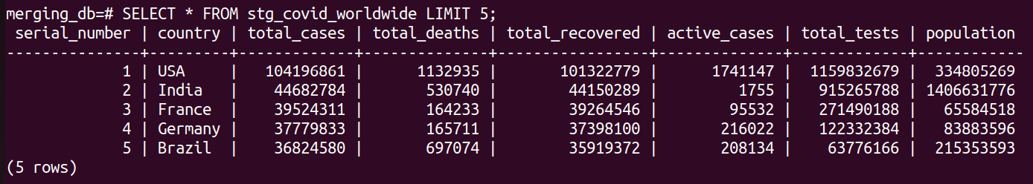

-- Check for NULLs

*SELECT COUNT(*) FILTER (WHERE total_tests IS NULL) AS null_tests,*

*COUNT(*) AS total_rows*

*FROM stg_covid_worldwide;*

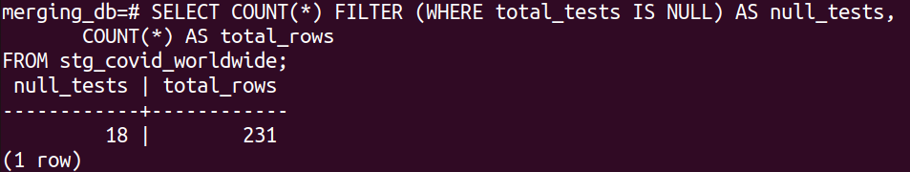

**Dimension Tables**

**Country Dimension Table**

*CREATE TABLE dim_country (*

*country_id SERIAL PRIMARY KEY,*

*country_name TEXT UNIQUE*

*);*

**Populate with Union of Countries**

*INSERT INTO dim_country (country_name)*

*SELECT DISTINCT country FROM stg_covid_worldwide*

*UNION*

*SELECT DISTINCT country FROM stg_economic_indicators*

*ON CONFLICT DO NOTHING;*

**Date Dimension Table**

*CREATE TABLE dim_date (*

*date_id SERIAL PRIMARY KEY,*

*date DATE UNIQUE,*

*year INT,*

*month INT,*

*quarter INT*

*);*

**Populate from Economic Indicators**

*INSERT INTO dim_date (date, year, month, quarter)*

*SELECT DISTINCT*

*date,*

*EXTRACT(YEAR FROM date)::INT,*

*EXTRACT(MONTH FROM date)::INT,*

*EXTRACT(QUARTER FROM date)::INT*

*FROM stg_economic_indicators*

*ON CONFLICT DO NOTHING;*

**Fact Tables**

**Economic Indicators Fact Table**

*CREATE TABLE fact_economics (*

*country_id INT REFERENCES dim_country(country_id),*

*date_id INT REFERENCES dim_date(date_id),*

*inflation_rate NUMERIC,*

*gdp_growth_rate NUMERIC,*

*unemployment_rate NUMERIC,*

*interest_rate NUMERIC,*

*stock_index_value NUMERIC*

*);*

**Populate Fact Table**

*INSERT INTO fact_economics (country_id, date_id, inflation_rate, gdp_growth_rate, unemployment_rate, interest_rate, stock_index_value)*

*SELECT*

*dc.country_id,*

*dd.date_id,*

*sei.inflation_rate,*

*sei.gdp_growth_rate,*

*sei.unemployment_rate,*

*sei.interest_rate,*

*sei.stock_index_value*

*FROM stg_economic_indicators sei*

*JOIN dim_country dc ON dc.country_name = sei.country*

*JOIN dim_date dd ON dd.date = sei.date;*

**COVID Data Fact Table**

*CREATE TABLE fact_covid (*

*country_id INT REFERENCES dim_country(country_id),*

*total_cases BIGINT,*

*total_deaths BIGINT,*

*total_recovered BIGINT,*

*active_cases BIGINT,*

*total_tests BIGINT,*

*population BIGINT*

*);*

**Populate Fact Table**

*INSERT INTO fact_covid (country_id, total_cases, total_deaths, total_recovered, active_cases, total_tests, population)*

*SELECT*

*dc.country_id,*

*scw.total_cases,*

*scw.total_deaths,*

*scw.total_recovered,*

*scw.active_cases,*

*scw.total_tests,*

*scw.population*

*FROM stg_covid_worldwide scw*

*JOIN dim_country dc ON dc.country_name = scw.country;*

**Unified Analytical View**

**Create View for Unified Access**

*CREATE VIEW view_country_snapshot AS*

*SELECT*

*dc.country_name,*

*dd.year,*

*dd.month,*

*fe.inflation_rate,*

*fe.gdp_growth_rate,*

*fe.unemployment_rate,*

*fe.interest_rate,*

*fe.stock_index_value,*

*fc.total_cases,*

*fc.total_deaths,*

*fc.total_recovered,*

*fc.active_cases,*

*fc.total_tests,*

*fc.population*

*FROM fact_economics fe*

*JOIN dim_country dc ON fe.country_id = dc.country_id*

*JOIN dim_date dd ON fe.date_id = dd.date_id*

*JOIN fact_covid fc ON fc.country_id = dc.country_id*

*WHERE dd.year = 2023;*

**Validation and Querying the Unified View**

**Preview Unified Data**

*psql -U postgres -d merging_db -h localhost *

*-c "SELECT * FROM view_country_snapshot LIMIT 10;"*

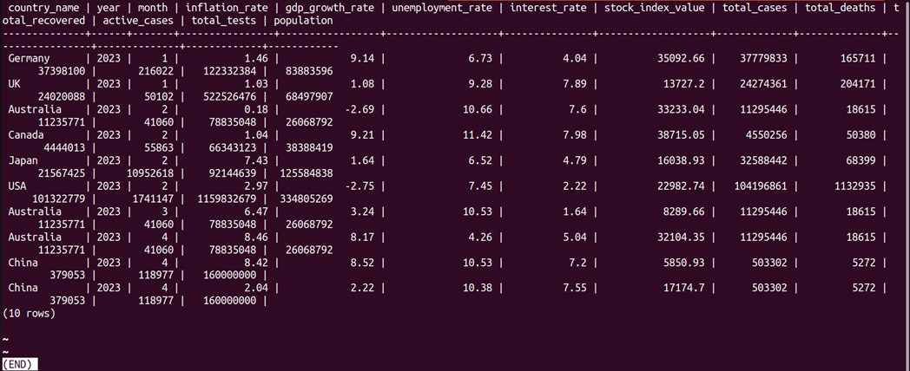

**Filter by Country and Time**

*SELECT \**

*FROM view_country_snapshot*

*WHERE country_name = 'USA' AND year = 2023*

*ORDER BY month;*

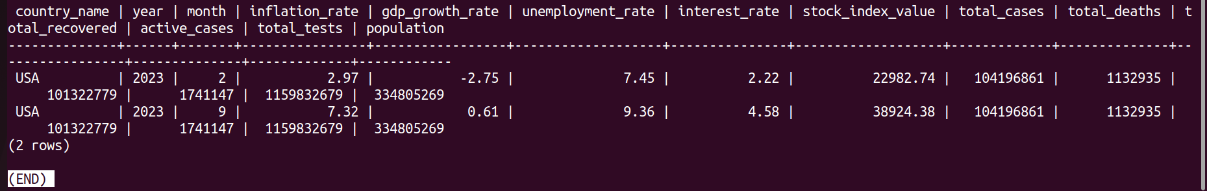

**Aggregate Analysis**

*SELECT*

*country_name,*

*AVG(gdp_growth_rate) AS avg_gdp_growth,*

*total_cases*

*FROM view_country_snapshot*

*WHERE year = 2023*

*GROUP BY country_name, total_cases*

*ORDER BY avg_gdp_growth DESC*

*LIMIT 20;*

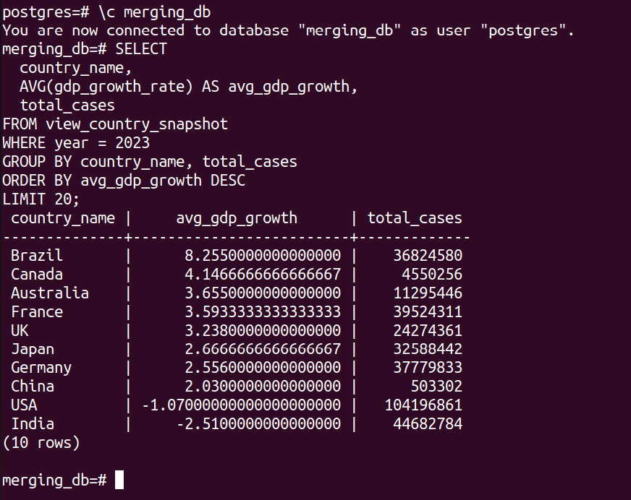

**Conclusion**

Through structured staging, transformation, and modeling, the unrelated COVID and economic datasets have been successfully merged into a single PostgreSQL-based data warehouse. Analysts can now seamlessly explore temporal and regional relationships between public health metrics and economic performance from a unified interface.